**Resource Utilization**

**Duration : 30 days**

**EC2-Instance**

#### **BCPROD-P1**

**CPU Utilization(%):**

**Average : 2.96**  **Min : 0.92** **Max : 20.76**

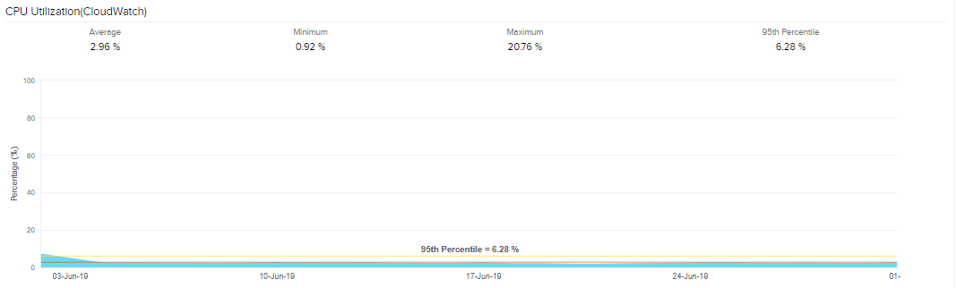

##### Network Traffic(Bytes)

**Received**

**Average :** 143,807,525.33 **Min :** 5,291,265 **Max :** 940,839,321.6

**Sent**

**Average :** 43,999,538.51 **Min :** 4,145,818.2 **Max :** 1,049,478,091.6

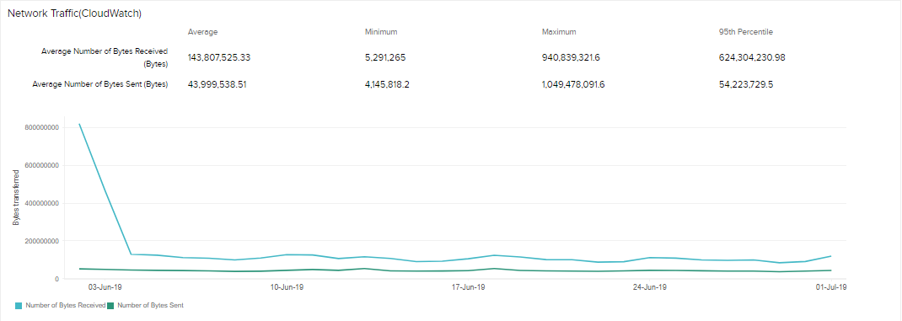

#### BCPROD-P2

**CPU Utilization(%):**

**Average : 2.98** **Min : 01.03** **Max : 20.85**

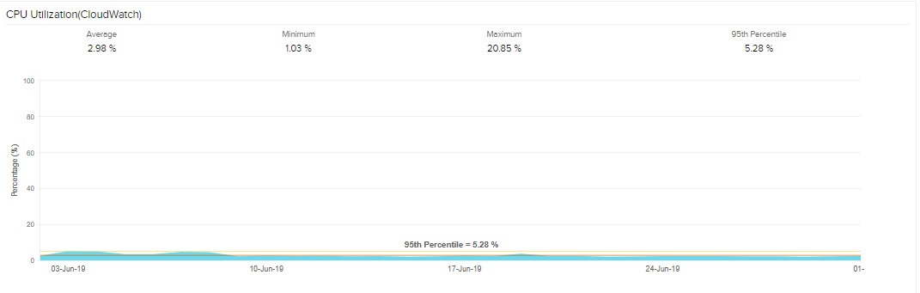

##### **Network Traffic****(Bytes)**

**Received**

**Average : 180,877,549.1**  **Min : 9,494,000.6** **Max : 3,987,442,628.6**

**Sent**

**Average : 52,588,509.08** **Min : 52,588,509.08** **Max : 521,408,428.6**

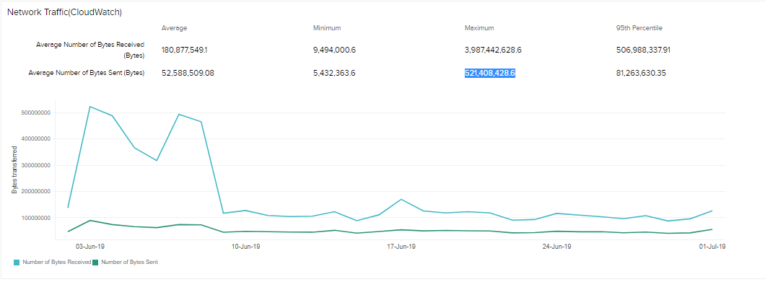

#### BCPROD-P3

**CPU Utilization(%):**

**Average : 1.89** **Min : 0.71** **Max : 11.67**

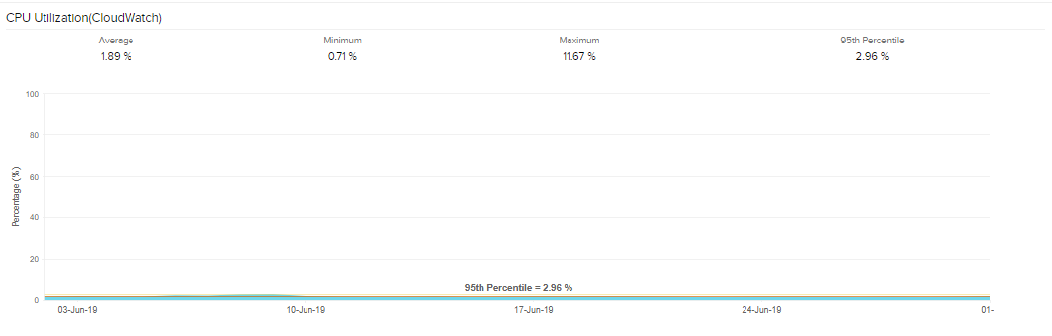

##### **Network Traffic****(Bytes)**

**Received**

**Average :** 148,966,108.83 **Min :** 975,994.67 **Max :** 3,335,789,273

**Sent**

**Average :** 46,665,839.93 **Min :** 811,728 **Max :**781,603,511.33

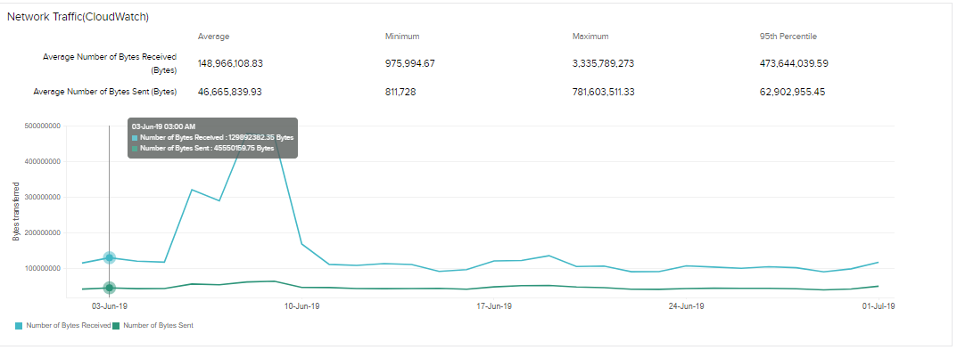

#### BCPROD-P4

**CPU Utilization(%):**

**Average : 1.76** **Min : 0.65** **Max : 12.27**

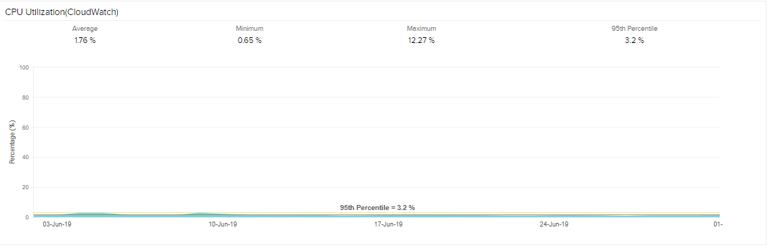

##### **Network Traffic****(Bytes)**

**Received**

**Average :** 157,897,525.57 **Min :** 7,415,452.83 **Max :** 1,073,912,777.5

**Sent**

**Average :** 49,486,421.45 **Min :** 3,205,522.5 **Max :**474,154,708.83

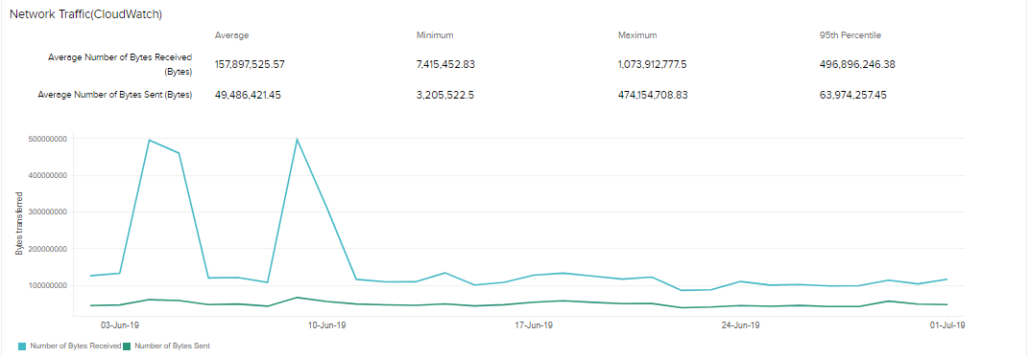

**RDS Instance :**

#### bcdevinstance01

**CPU Utilization(%):**

**Average : 1.49** **Min : 1.32** **Max : 9.17**

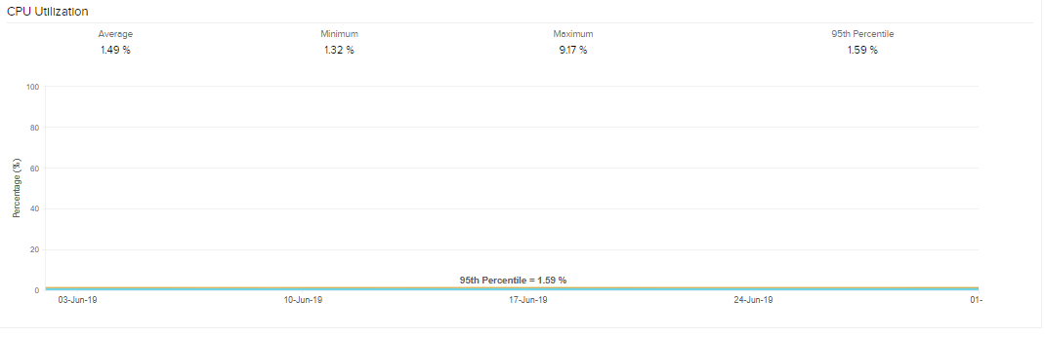

##### **Database Connections****(Count)**

**Average : 0.31** **Min : 0** **Max : 210**

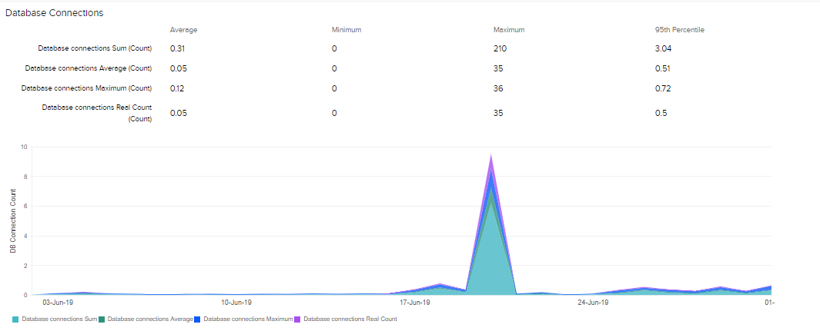

##### **Freeable Memory****(Bytes)**

**Average :** 2,964,787,622.75 **Min :** 2,873,410,218.67 **Max :**3,147,089,237.33

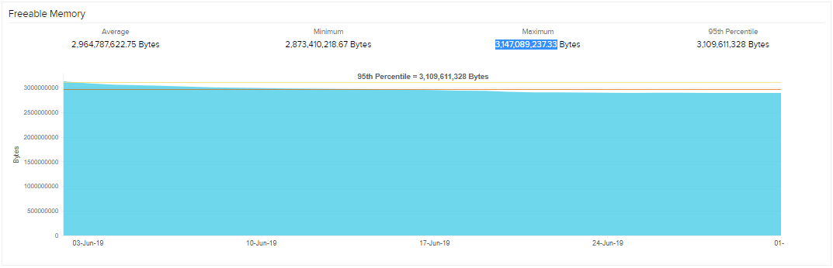

##### bcprodasl

**CPU Utilization(%):**

**Average : 1.09** **Min : 0.94** **Max : 5.84**

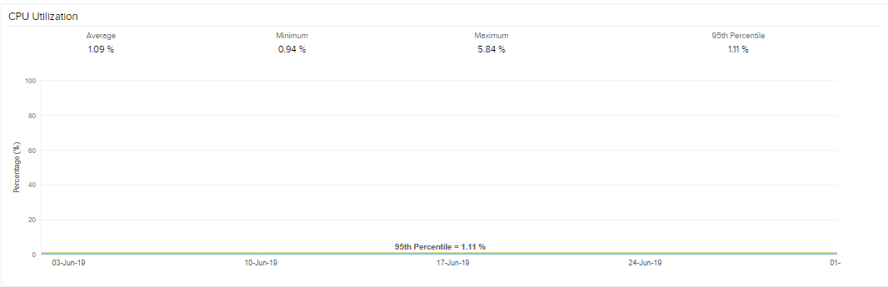

##### **Database Connections****(Count)**

**Average : 0.15** **Min : 0** **Max : 8**

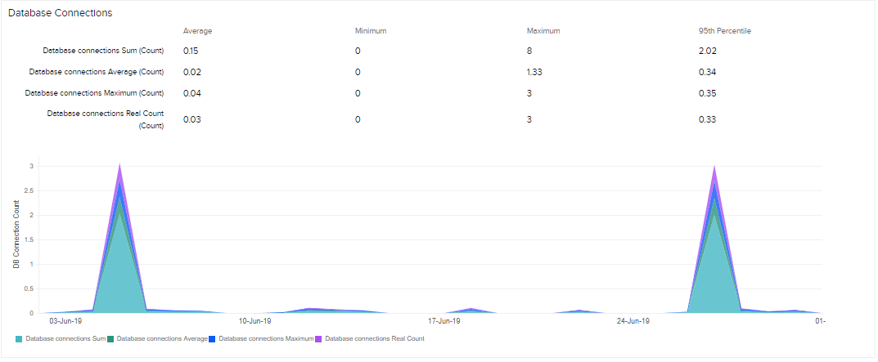

##### Freeable Memory(Bytes)

**Average :** 554,952,571.02 **Min :** 533,511,509.33 **Max :**586,772,480

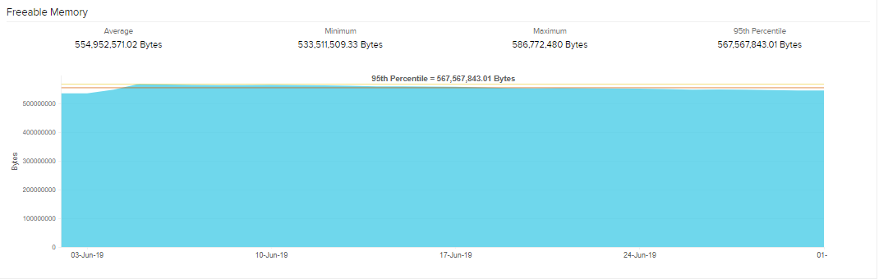

#### bcprodinstance01

**CPU Utilization(%):**

**Average : 7.02** **Min : 2.91** **Max : 99.71**

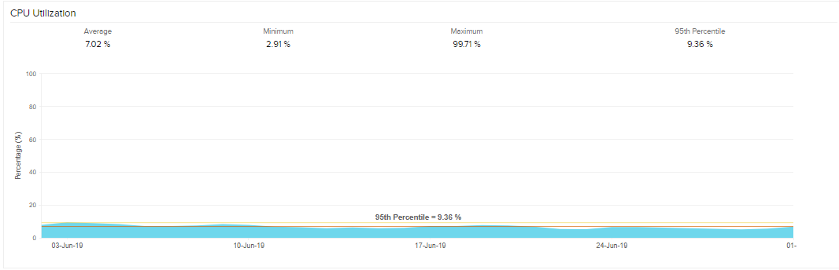

##### **Database Connections****(Count)**

**Average : 23.81** **Min : 0** **Max : 622**

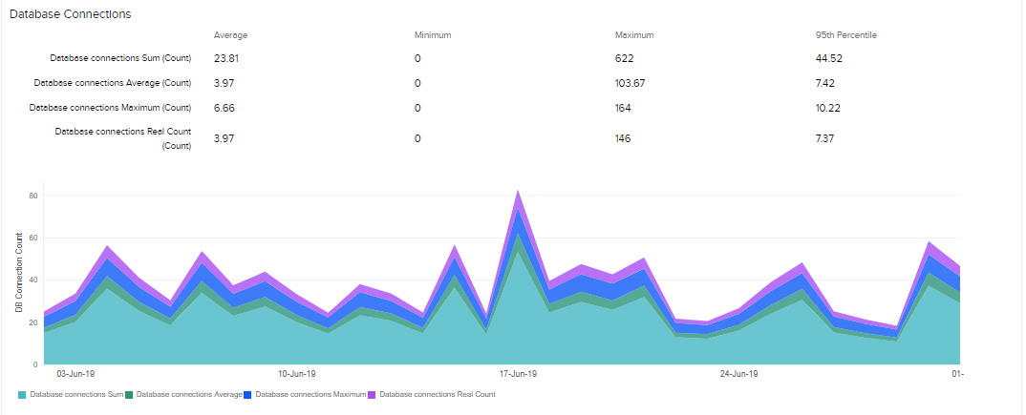

##### Freeable Memory(Bytes)

**Average :** 105,288,243,323.27 **Min :** 104,304,858,453.33 **Max :**106,164,925,098.67

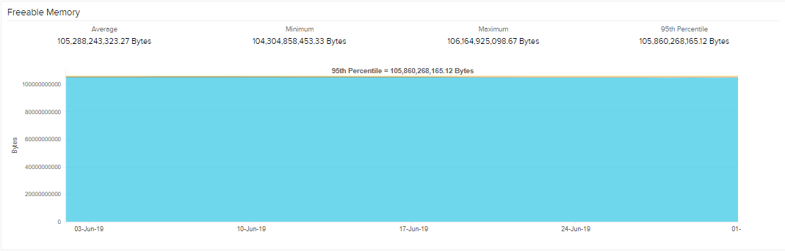

**Elastic Cache**

**bcprodcache01**

#### 0001

**CPU Utilization(%):**

**Average : 2.18** **Min : 1.17** **Max : 6.53**

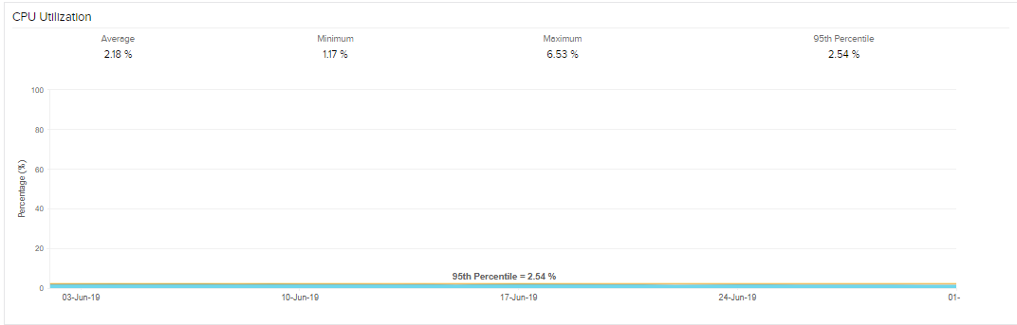

##### Bytes Used For Cache(MB)

**Average :** 23,303.56 **Min :** 23,285.16 **Max :** 23,317.95

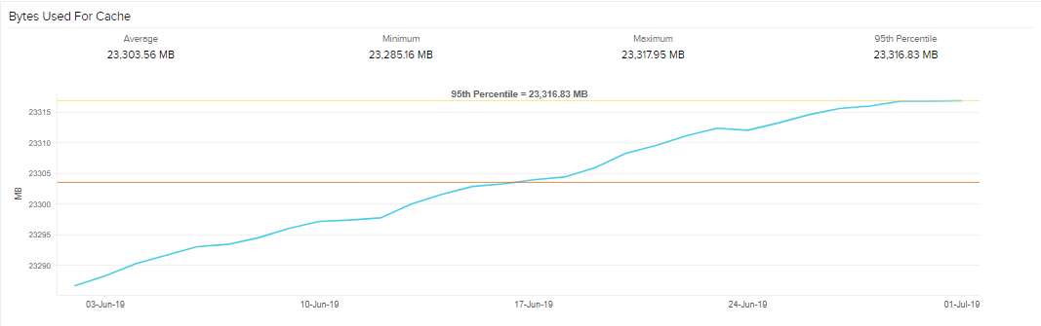

##### 0002

**CPU Utilization(%):**

**Average : 2.18** **Min : 1.17** **Max : 6.53**

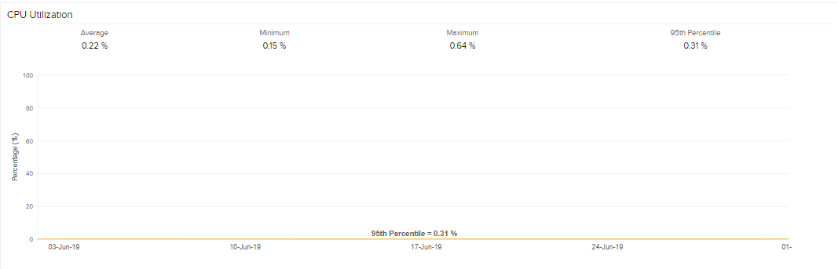

##### Bytes Used For Cache(MB)

**Average :** 2.21 **Min :** 0 **Max :** 109.42

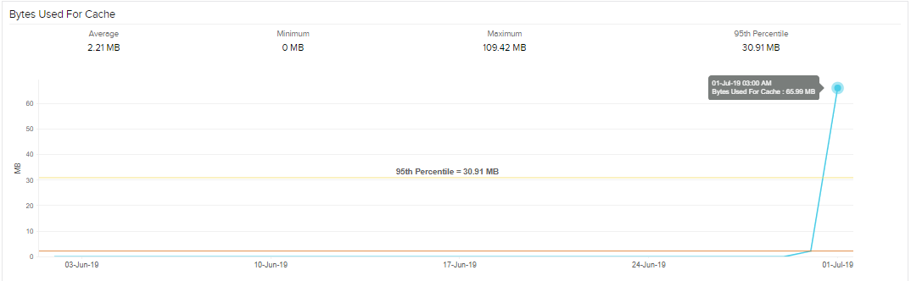

**bcdevcache-temp**

#### 0001

**CPU Utilization(%):**

**Average : 1.06** **Min : 0.95** **Max : 2**

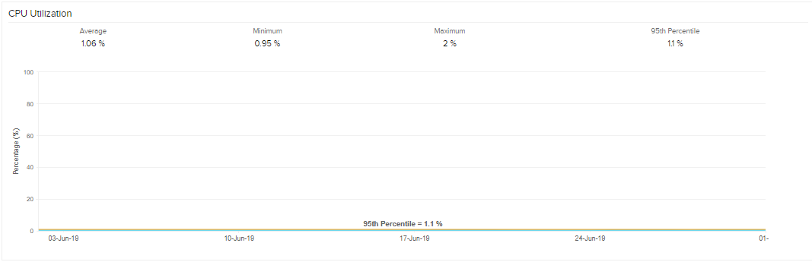

##### Bytes Used For Cache(MB)

**Average :** 362.26 **Min :**360.6 **Max :** 366.92

